API Docs and testing manual:

End Points :

1. **Adding Shop**

URL : localhost:8080/rest/shop

Method : POST

Content-type Supported : application/json

content should be in request body in specific format e.g. :

{

"name":"cafegcd",

"address":{

"addressline":"ccd , chinhat, Lucknow",

"postalcode":"227105"

}

}

Postman Example to add shop:

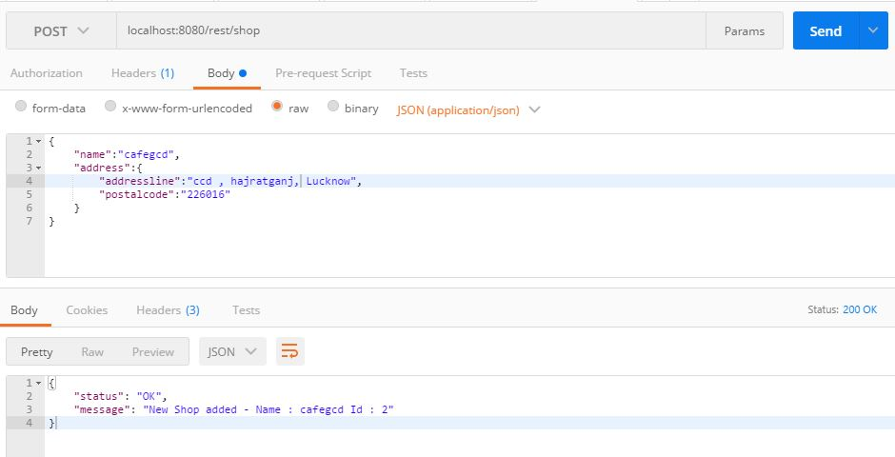

when adding shop with same name:

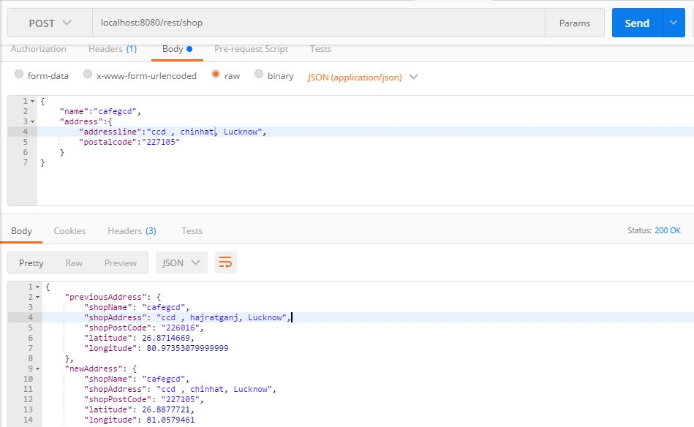

2. **Finding shop**

URL : localhost:8080/rest/shop?latitude=26.8915707&longitude=80.9926327

Method : GET

Postman example:

